Name: Nadeem Mohamed

Student Number: ST10486607

Subject: Web Development

Group:03

Cover Page 1
Table of Contents 2
Proposal 1: Urban Brew Coffee Website 3
1. Organization Overview 3
2. Website Goals and Objectives 3
3. Current Website Analysis 3
4. Features and Functionality 3
5. Design and UX 3
6. Wireframe 4
7. Technical Requirements 4
8. Timeline 4
9. Budget 4

Proposal 1: Urban Brew Coffee Website

1. Organization Overview
Founded in 2019, Urban Brew Coffee is a stand-alone coffee store. It focuses on providing high-quality coffee items while establishing a calm and friendly atmosphere for clients. Through social media marketing and word-of-mouth, the company has steadily expanded.
Our mission is to provide outstanding service and superior coffee. Vision: To become the area's top coffee destination. Students, young professionals, and remote workers between the ages of 18 and 40 are the target audience.

2. Website Goals and Objectives
The website's objectives are to raise brand awareness, draw in new clients, and offer an online buying system. It will act as a focal point for promotions and information.
Increased traffic, online sales, and customer interaction indicators are examples of KPIs.

3. Current Website Analysis
The company now uses social media and doesn't have a proper website. This restricts professionalism and accessibility.
Creating a responsive website with ordering features is one improvement.

4. Features and Functionality A homepage, menu page, contact page, about us page, gallery page, and online ordering system will all be part of the website. Promotions are extra features.

5. Design and UX Warm colors like cream and brown will be used in the design to represent the company identity. The design will be straightforward, tidy, and easy to use. The navigation will be responsive to mobile devices and easy to use.

6. Wireframe
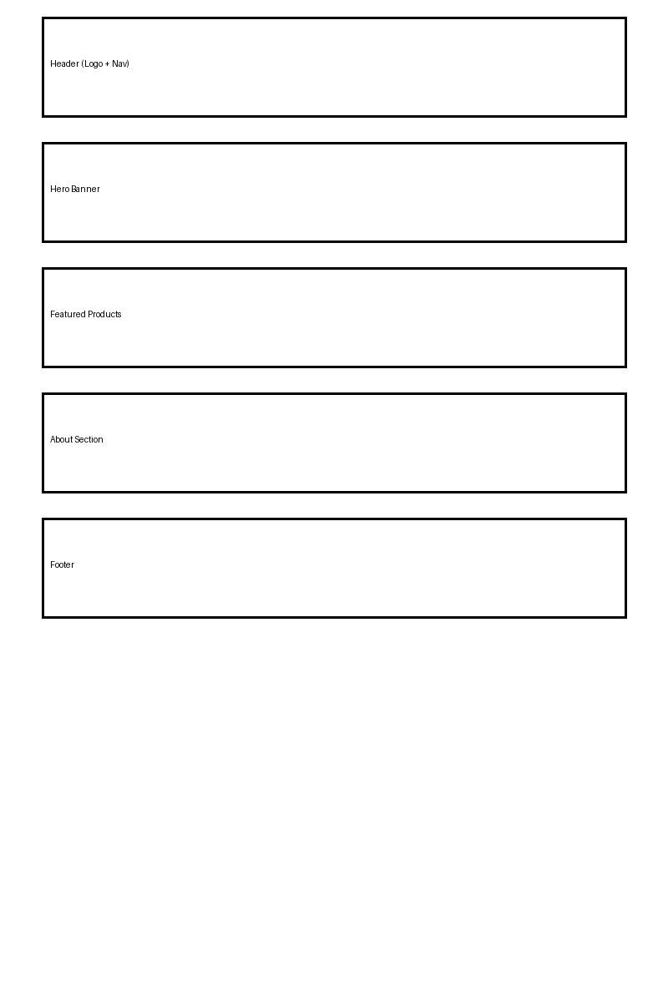

7. Technical Requirements HTML will be used in the construction of the website.

8. Timeline
Week 1–2: Planning and design
Week 3–4: Development
Week 5: Testing
Week 6: Launch

9. Budget
Development (R5,000), hosting (R1,200/year), and maintenance (R500/month) are all included in the estimated cost.

